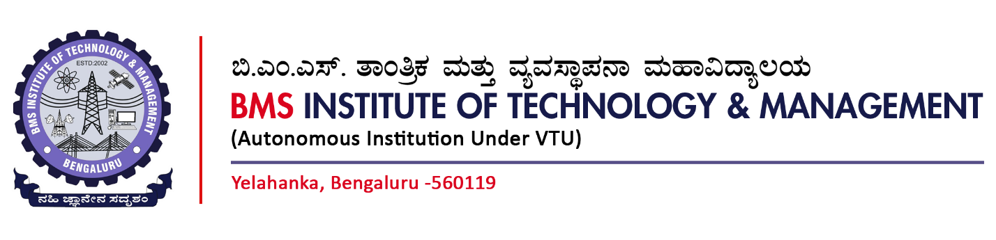

Department of MCA
(Accredited by NBA, New Delhi)

Project Work – Phase-I - MMCA34 (2024-26 Batch)

Name of the Student: SANDHYA.A USN:1BY24MC069

Title of the Project: Design and Implementation of a High-Efficiency Encrypted File Vault for Strengthening Data Security in Distributed Systems.

Project Guide: Prof. Ashwitha. K

Synopsis Evaluation Rubrics

Criteria | Excellent (8–10) | Good (5–7) | Needs Improvement (1–4)
Overall Quality of Synopsis (Introduction, Literature Survey, Problem Statement, SDG Alignment, Proposed Solution, Modules, Tools & Technologies) | Well-structured, coherent, and comprehensive; problem statement is clear; strong SDG mapping; thorough literature review; innovative and feasible proposed solution; logically identified modules; appropriate and well-justified tools/technologies | Adequate but with minor gaps; problem statement defined but objectives need refinement; SDG mapping present but weak; literature review covers limited sources; solution feasible but less innovative; modules/tools identified but lack detail | Poorly structured, vague, or incomplete; problem statement unclear; SDG mapping missing/irrelevant; weak or no literature survey; proposed solution impractical; modules and tools not well defined
Max. Marks | 10
Marks Obtained

Signature of Project Guide



Department of MCA
(Accredited by NBA, New Delhi)

Project Work – Phase-I - MMCA34 (2024-26 Batch)

Synopsis

Name of the Student: SANDHYA.A USN: 1BY24MC069

Title of the Project: Design and Implementation of a High-Efficiency Encrypted File Vault for Strengthening Data Security in Distributed Systems.

Project Guide: Prof. Ashwitha. K

Sl. No | Contents | Page No.
1. | Introduction | 1
2. | Literature Survey | 1-2
3. | Problem Statement with aims and objectives | 3
4. | SDG Alignment | 4
5. | Proposed Solution | 4
6. | Modules Identified | 5
7. | Tools and Technologies identified | 6

